**NAME:** MUHHAMAD ABUBAKR

**ROLL NO:** 25K-0503

**CLASS & SECTION:** BCS-1K

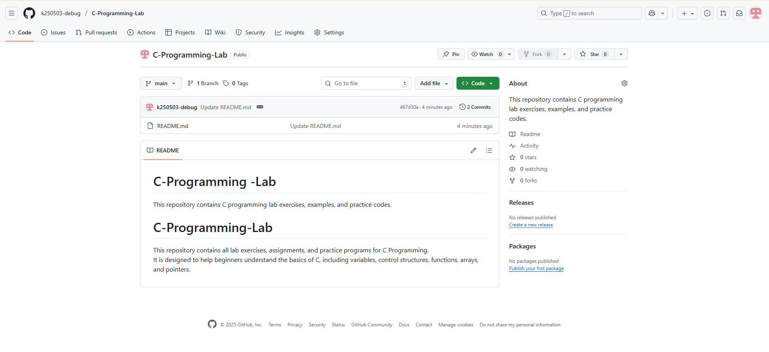**TASK #1:**

**TASK #2:**

Program:

OUTPUT:

**TASK #3:**

Program:

OUTPUT: